**DAILY ONLINE ACTIVITIES SUMMARY**

|  |  |  |  |  |  |  |  |  |
| --- | --- | --- | --- | --- | --- | --- | --- | --- |
| **Date:** | **21/05/2020** | | | | | **Name:** | **Albin Francis** | |
| **Sem & Sec** | **8th sem,A** | | | | | **USN:** | **4AL16CS008** | |
| **Online Test Summary** | | | | | | | | |
| **Subject** | | **SMS** | | | | | | |
| **Max. Marks** | | **60** | | **Score** | | | **43** | |
| **Certification Course Summary** | | | | | | | | |
| **Course** | **Getting Started To Hadoop** | | | | | | | |
| **Certificate Provider** | | | **GreatLearning** | | **Duration** | | | **20mins** |
| **Coding Challenges** | | | | | | | | |
| **Problem Statement: C Program to Reverse a Linked List in groups of given size** | | | | | | | | |
| **Status: Solved** | | | | | | | | |
| **Uploaded the report in Github** | | | | | **Yes** | | | |
| **If yes Repository name** | | | | | **albinfrancis008** | | | |
| **Uploaded the report in slack** | | | | | **Yes** | | | |

Online Test Details: (Attach the snapshot and briefly write the report for the same)

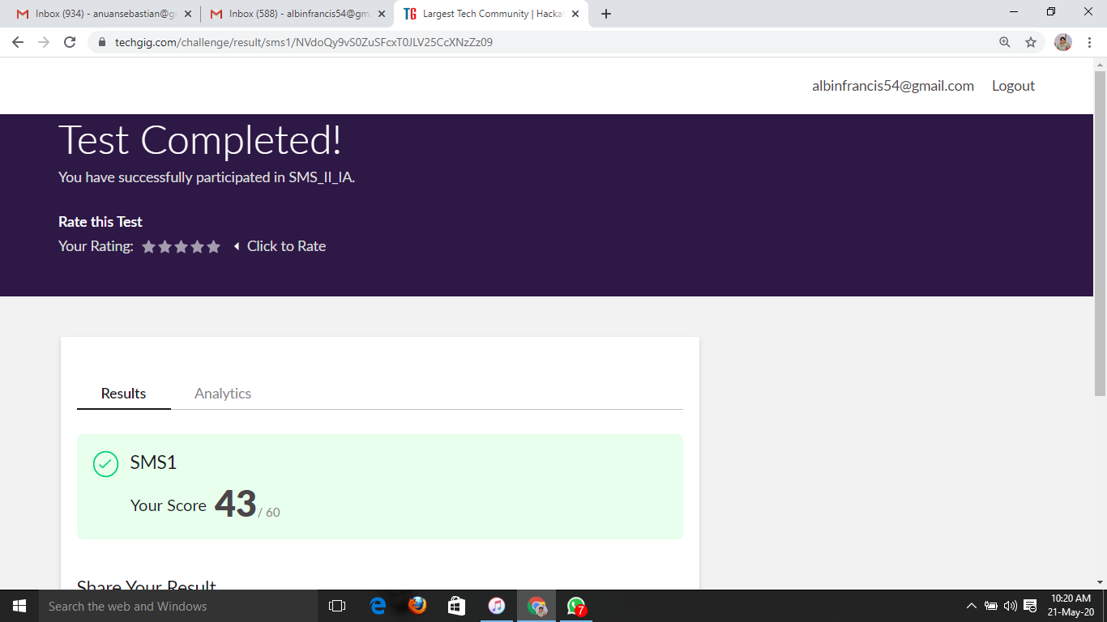

Certification Course Details: (Attach the snapshot and briefly write the report for the same)

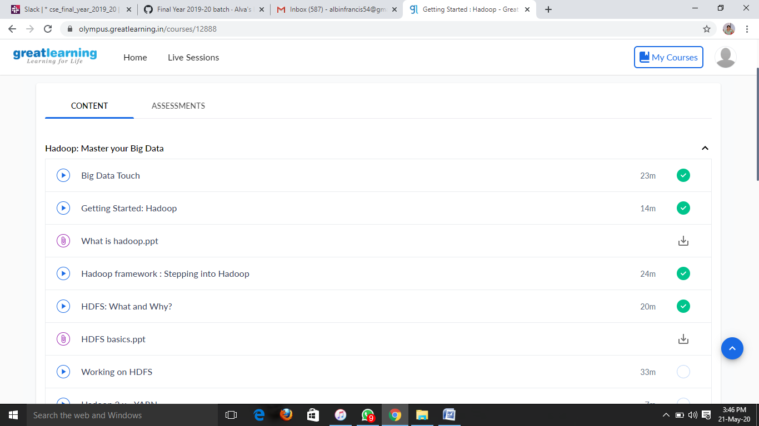

**What is HDFS?**

**MapReduce** is the data processing layer of Hadoop. It is a software framework for easily writing applications that process the vast amount of structured and unstructured data stored in the [Hadoop Distributed Filesystem (HDFS)](http://data-flair.training/blogs/comprehensive-hdfs-guide-introduction-architecture-data-read-write-tutorial/).

**InputSplit** in Hadoop **[MapReduce](http://data-flair.training/blogs/hadoop-mapreduce-tutorial/)**is the logical representation of data. It describes a unit of work that contains a single map task in a MapReduce program.  
Hadoop InputSplit represents the data which is processed by an individual [Mapper](http://data-flair.training/blogs/mapper-in-hadoop-mapreduce/). The split is divided into records. Hence, the mapper process each record (which is a [**key-value pair**](http://data-flair.training/blogs/key-value-pairs-hadoop-mapreduce/)).

Replication factor dictates how many copies of a block should be kept in your cluster.The replication factor is 3 by default (there would be one original block and two replicas) and hence any file you create in HDFS will have a replication factor of 3 and each block from the file will be copied to 3 different nodes in your cluster.

Coding Challenges Details: (Attach the snapshot and briefly write the report for the same)

Write a C Program to Reverse a Linked List in groups of given size.

#include<stdio.h>

#include<stdlib.h>

struct Node

{

int data;

struct Node* next;

};

struct Node reverse(struct Node head,int k)

{

struct Node current= head;

struct Node next= Null;

struct Node prev= Null;

int count = 0;

while(current!=Null && count<k)

{

next= current->next;

current->next = prev;

prev= current;

current= next;

count++;

}

if ( next!=Null)

head->next= reverse( next,k);

return prev;

}

void push( struct Node ==head_ref,int new_data)

{

struct Node= new_node= (struct Node*) malloc(sizeof(struct Node));

}

}

int main()

{

Struct node *prev,*head,*p;

int n,i;

printf ("number of elements:");

scanf("%d",&n);

head=NULL;

for(i=0;i<n;i++)

{

p=malloc(sizeof(struct node));

scanf("%d",&p->data);

p->next=NULL;

if(head==NULL)

head=p;

else

prev->next=p;

prev=p;

}

return 0;

}